TASK 1
You should spend about 20 minutes on this task. Write at least 150 words.
After you finish, use the checklist to evaluate your writing task. Then, compare your task with the sample answer.

The graphs below give information about computer ownership as a percentage of the population between 2002 and 2010, and by level of education for the years 2002 and 2010.
Summarise the information by selecting and reporting the main features, and make comparisons where relevant.
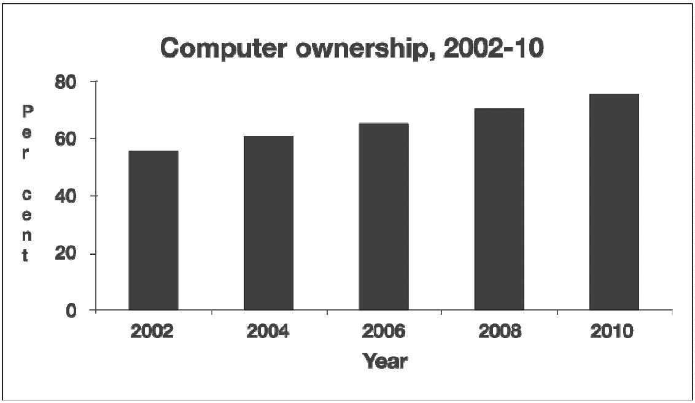
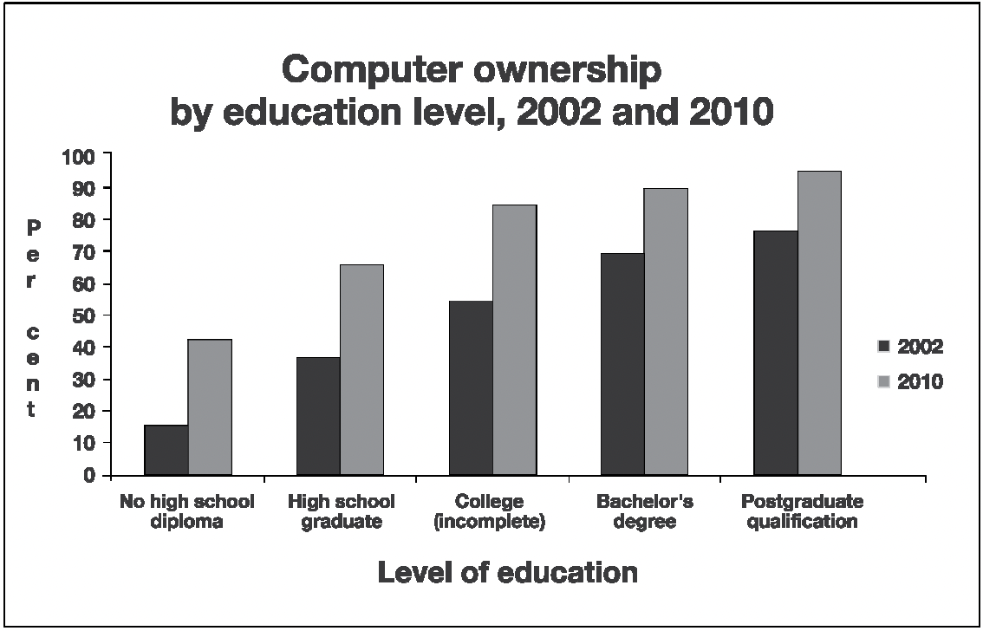

TASK 2
You should spend about 40 minutes on this task. Write at least 250 words
After you finish, use the checklist to evaluate your writing task. Then, compare your task with the sample answer.

Write about the following topic: A person’s worth nowadays seems to be judged according to social status and material possessions. Old-fashioned values, such as honour, kindness and trust, no longer seem important.
Give reasons for your answer and include any relevant examples from your own knowledge or experience.

.

